TRADEMARK SEARCH REQUEST FORM

PROPOSED MARK: ________________________________________

GOODS OR SERVICES FOR THE MARK: ___________________________________________________________________

___________________________________________________________________

OWNER OF MARK: (if more than one, attach the information):

Name: __________________________________________________________________
Full Address: ___________________________________________________________________ ___________________________________________________________________

Email: _____________________________________
Phone: (______)____________________

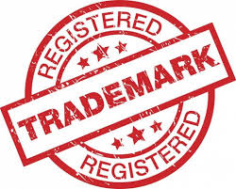

CREDIT CARD AUTHORIZATION FORM

Please charge the amount of $_______________ against credit card:

Card type: ___ Mastercard ___Visa ___Discover

Card #_____________________________ Expires: ___ / ___

Security Code (on back of card) ______

Cardholder Signature: ________________________________________
Date: ___ /___ / ______

Print Cardholder Signature: ________________________________________________

NOTE: The Inventor(s) agrees to retain the services of PATENT OFFICE RESEARCH to perform a search in the records of the U.S. Patent & Trademark Office. The results of such search shall be sent to Inventor upon completion, in about 10 days.

